Greetings on this fine October day!

I hope this email finds you well. It's hard to believe that 2024 is winding down. What a fast and furious nine and a half months! With October comes our fun general meeting (more on that later), and our thoughts turn to leadership for the next year. Who will lead our organization in 2025? One thing is sure: all of the present board members have expressed that they won't be returning in the same position next year. That leaves the four elected board positions open: President, Vice President, Secretary, and Treasurer. The other positions--Historian, Membership Chair, Newsletter Editor, Hospitality Chair, and Website--are all appointed by the President.

Won't you consider serving the East Texas Writers Guild in a leadership capacity? We need your nominations by October 31. It is okay and actually great to nominate yourself if you're interested. Nominees for the elected board positions will be placed on a ballot and emailed to the membership for a vote November 1. You don't have to be published to serve, but you do have to be an active member in good standing. Your membership information should come up on the log-in page when you visit our website [etwritersguild.org](https://emea01.safelinks.protection.outlook.com/?url=http%3A%2F%2Fetwritersguild.org%2F&data=05%7C02%7C%7Cc898633fd9e6459c677d08dce88d1430%7C84df9e7fe9f640afb435aaaaaaaaaaaa%7C1%7C0%7C638640939855209276%7CUnknown%7CTWFpbGZsb3d8eyJWIjoiMC4wLjAwMDAiLCJQIjoiV2luMzIiLCJBTiI6Ik1haWwiLCJXVCI6Mn0%3D%7C0%7C%7C%7C&sdata=ldxs5W1ijWphtwrEAn18HVJg3ro00r3mOAdpISA308s%3D&reserved=0). Remember that concerned letter I sent out a month or so ago? The future of the Guild depends on you.

October General Meeting

It's time for our annual Scary Stories meeting! You are invited to share a scary story with us at our next general meeting on October 14 at 6:30 pm. We meet at the Genecov Room of the Tyler Area Chamber of Commerce building at 315 N. Broadway, with parking and entrance on Line Street. Bring your story to read (five-minute limit, please), your favorite fall or Halloween treat to share, and books to sign and sell, if you're an author. If you bring books, please limit your display to the area in front of you at your table. We won't have extra tables for books.

You are also invited to join us at Margarita's Mexican Restaurant for an early dinner at 5:00 pm. The restaurant is located at 1327 E. Front St. in Tyler.

September Meeting Notes

If you missed our September meeting, you missed a real treat. Children's book author Louise Jackson was our featured speaker, and she shared her interesting journey as an author, with tips and encouragement for building great characters. Here is Laura Bentz's report on the meeting:

Louise Jackson Presents an Amazing Discussion on Character in our September 9, 2024 General Meeting!

In the first part of the meeting, we discussed the old and new club business. Nutz and Boltz will be on Monday, 9/16 at 6:30 at Braum’s on South Broadway. Next month, on October 7, we will have a special “Spooky Story” sharing time and a book-selling opportunity. BOD will be on the 2nd Monday.

Louise then read from her book, which is not yet published, tentatively called “Waiting for Paul,” and stressed the importance of believable characters in your writings. Her book is about a thirteen-year-old boy during the Civil War who is waiting for his father to come home. She emphasizes that the “character” has to be “rich” in personality and character. It would be best if you got the reader to like them and care that they win. She told about a book that won a Pulitzer Prize that gave a graphic description of African Americans coming from the South to the northern cities and what they went through on their journey with vivid and believable characters.

Other advice includes:

1. Making sure your main character has a flaw.

2. Always end your story with hope.

3. Reveal the character’s personality slowly.

4. Keep moving the story along.

5. Have a satisfying ending.

She also passed out some handouts during the meeting. Here are copies of them and pictures.

Coming up: Business Meeting on Zoom on Monday, October 7 and General Meeting on

Monday, October 14. We will have no speakers, but we will share our spooky stories.

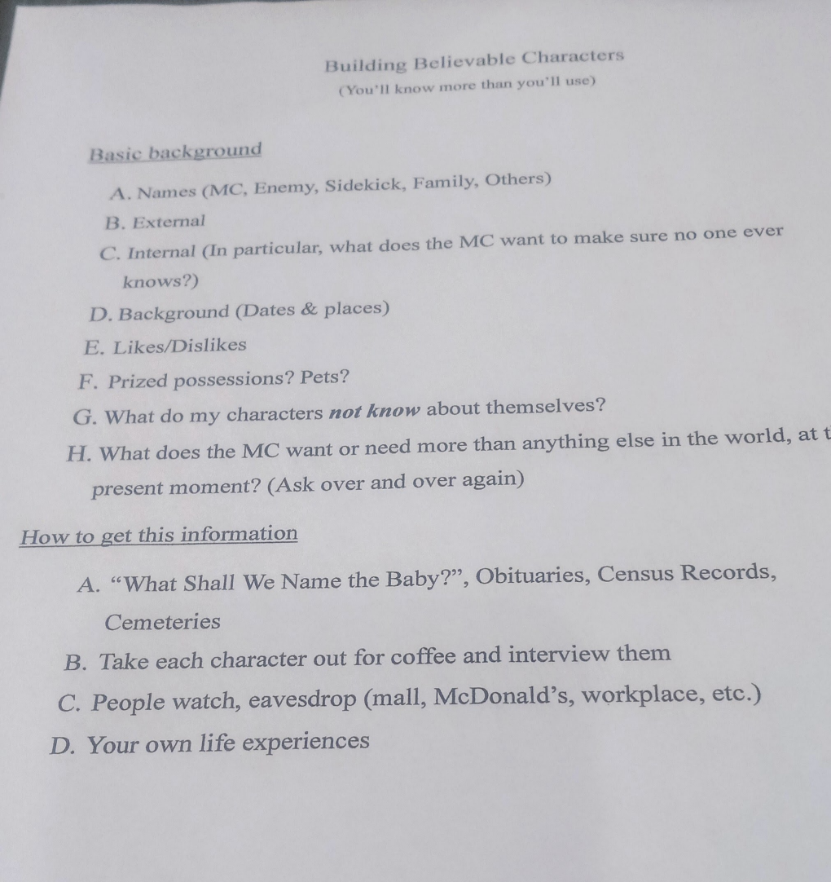

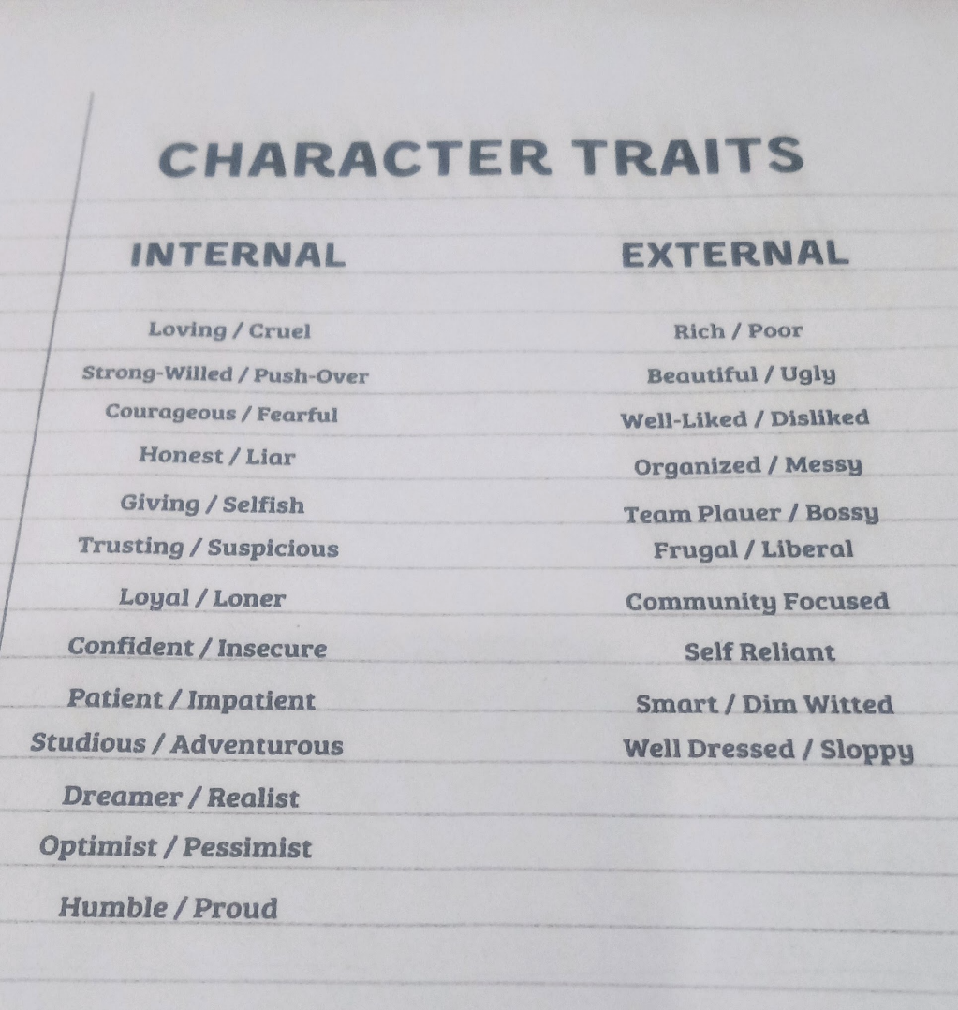

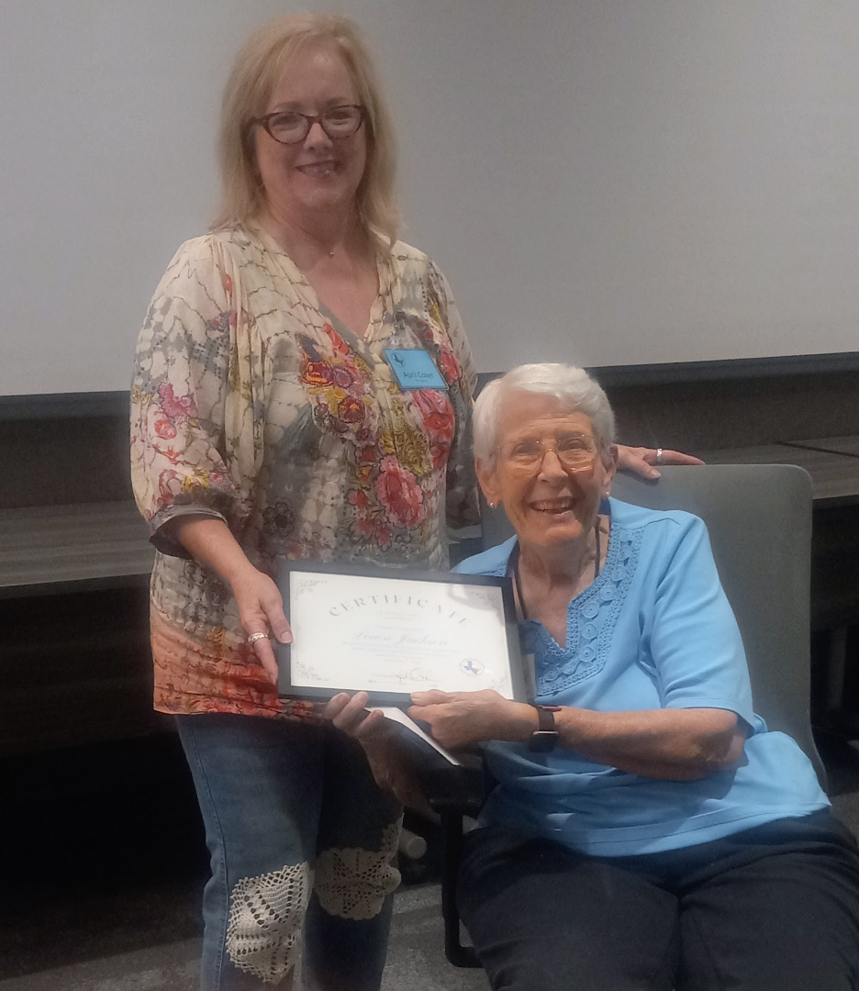

Upcoming Dates

October 21: Nutz & Boltz at Braum's Ice Cream at 7101 S. Broadway in Tyler at 6:30 pm. Lisa Holcomb will lead our discussion.

October 31: DEADLINE for officer nominations.

November 1: Ballot to be sent to membership.

November 4: Board of directors meeting via Zoom.

November 11: General meeting at Chamber. Brenda Haire to speak.

November 15: DEADLINE for voting for officers.

November 18: Nutz & Boltz at Braum's. Marsha Graham to lead.

December 2: Board of directors meeting.

December 3:  Announcement of 2025 ETWG Officers.

December 9: ETWG Christmas Party at Chamber.

That's it for this month! I hope to see you at the meeting Monday evening! Join us for dinner!

April Coker

ETWG President

 SHAPE \* MERGEFORMAT